|  |  |
| --- | --- |
| **AGSendCP** | |
|  | ID |
|  | AGID |
|  | CPID |
|  | ICID |
|  | Date |
|  | |

**Contrats**

ID

AGID

CLID

CPID

ITID

[Start Date]

[End Date]

Price

Description

**Client**

ID

Name

Last

Tel

**Incidents**

ID AGID CLID CTID

Date CLBILL

Compensation Rapport

|  |  |
| --- | --- |
| **Agent** | |
|  | ID |
|  | Name |
|  | Last |
|  | Mail |
|  | Password |
|  | |

|  |  |
| --- | --- |
| **Company** | |
|  | ID |
|  | Name |
|  | Location |
|  | Fax |
|  | |

|  |  |
| --- | --- |
| **PayCollection** | |
|  | AGID |
|  | CLID |
|  | CTID |
|  | Date |
|  | |

**CPhaveIT**

CPID ITID

**InsuranceTypes**

ID

Code Ratio

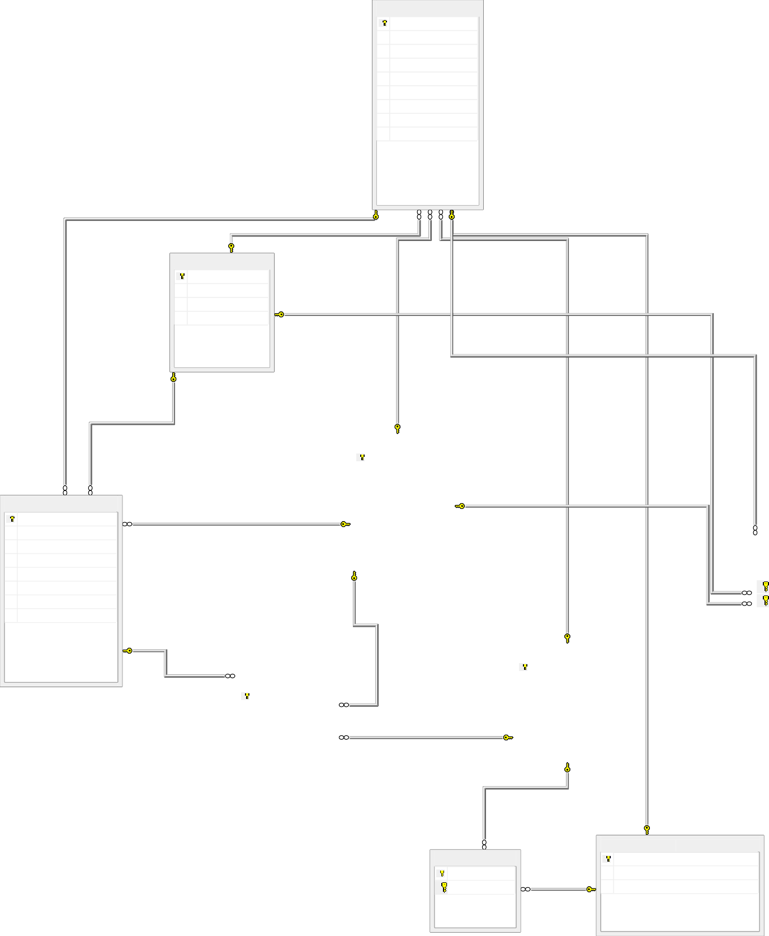2-1